
Orca 30

Handheld Data Terminal

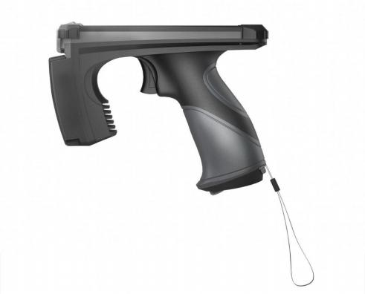

Salute to the classics Newly upgraded

1. Advantages


High Performance Computing Platform
Octa-core 64-bit Cortex-A55 processor (up to 2.0 GHz), plus a 200M RISC-V Co-processor make all kinds of massive data processing smoothly.
Android 14.0
Android 14.0 OS, keeps optimizing and upgrading.

Top Class Materials
Cast Aluminium + PC body, with tempered glass provide excellent rigidity + heat dissipation + electromagnetic shielding features. Soft material around the handle offers a comfortable grip.

Industrial-grade Components
Industrial-grade and military-grade components ensure stable operation in harsh environments.

Ultra Long Operating Time
Pistol style hot-swappable battery system makes backup battery more convenient to be restored, so that the operating time is unlimited.( Extra batteries are available.)
High-end UHF RFID Engine
Equipped with self-developed UHF RFID module, it is reputable in the industry for the outstanding reliability and stability and extremely strong multi-tag identification performance.
Outstanding Industrial Design
The idea was inspired by orca, and each single detail has been well refined. The appearance is compact, elegant and balanced, which makes the product eye-catching and impressive.

Excellent Mechanical Protection
Safety drop height 1.6m. IP64 protection grade.

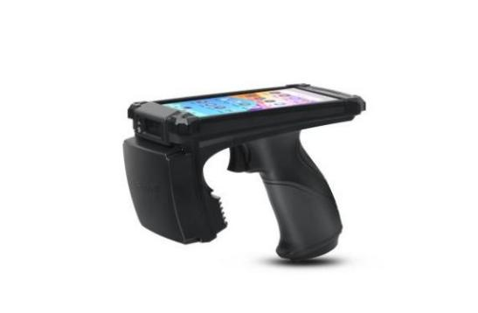
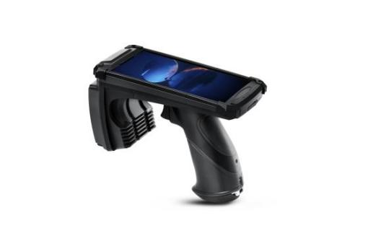
- Product views
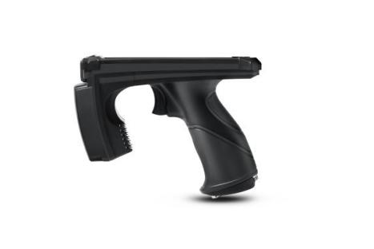

3. Electrical Parameters
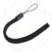

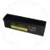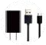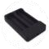
Android 14.0

Octa-core 64-bit Cortex-A55 /up to 2.0 GHz
+ a 200M RISC-V Co-processor

G57 MC1
4G+64G
5.0 inches/ 1280*720 / IPS / 180°view angle
1.1mm thickness tempered glass/ 5-dot touch/ operable with gloves
Pistol style hotswapping battery system
3 ALPS buttons/ Operating force 2.2N /
Operating life 1 million cycles
OMRON button / Operating force 1.27N/
Operating life 10 million cycles
7,000mAh chargeable Ii-polymer battery
Micro SIM card slot*1 / TF card slot*1
(Supports up to 256GB Micro SD card)
USB 3.0 TYPE C (OTG supported)
28mm*9mm*3.8mm
Button style / 10mm diameter

Operating System
CPU

GPU
RAM+ROM
LCD

Touch Screen

Hotswapping Battery
Power/Volume

Scan Trigger

Power
Card Slots

Interface
Speaker Size
Vibration

Data Collections
1D/2D Barcode
Datamatrix/QRCode/PDF417 US Planet/ UK Postal, etc.

UPC/EA SymbolSE955N/Code128/
Code39/Code93/Code11/lnterleaved 2 of 5/
Discrete 2 of 5/Chinese 2 of 5/
Codabar/MSI/ RSS, etc.

UHF RFID
-85dbm
EPC Global UHF Class 1 Gen 2/ ISO 18000-6C
902~928MHz, 865~868MHz

0~33dBm

>500tags/s

4dBi circularly polarized antenna

>12m (Tested with lmpinj E41binlay)
US, Canada and other regions
Following U.S. FCC
Europe and other regions following
ETSI EN 302 208
China
Korea
Malaysia

13 megapixels/ automatic focus/ flashlight

Global positioning system
Accessories

Charger &
Data Cable
Sensitivity
Protocol
Frequency
RF Output Power
Peak Inventory Speed
UHF Antenna
Read Distance
Supported Regions
GPS & GLONASS & Beidou
Charging Bay
Hanging Lace
Optional
Battery
Camera
2D
1D
Mechanical parameters
Materials Cast Aluminium + PC
Dimensions Body 167mm*82mm*130mm
Grip 111mm*38mm*47mm
Weight 615g（Battery included）
System Characteristics
Wireless Communications
WIFi Cmu
Bluetooth
LTE

Application Environment
-20℃~+60℃
-30℃~+70℃
5%RH - 95%RH (non -condensing) IP64
1.6m / 5.25ft
Operating Temp Storage Temp
Work Humidity Protection Grade
Safety Drop Height
2.4G/5G Dual-Band Bluetooth 5.0
Supported

